Information
Exhibitor Name
(Company Name)
Website
Address
Name of Applicant |  | Position
Tel. |  | E-mail

Application Details
- | Unit Price | Quantity | Total Price
Basic Booth ( 2m x 2m ) | USD 5,000 / 1booth | ( ) booth | USD ( )

- Offering : Backwall (2m x 2.5m), Information Desk(1ea), Chair(1ea)  - Graphic design on the backwall should be worked on by the Exhibitor and submitted to the organizers as ai and jpg file. ( Graphic Size : 2m(L) x 2.45m(W) )  - The location of the booth will be determined by the organizer | 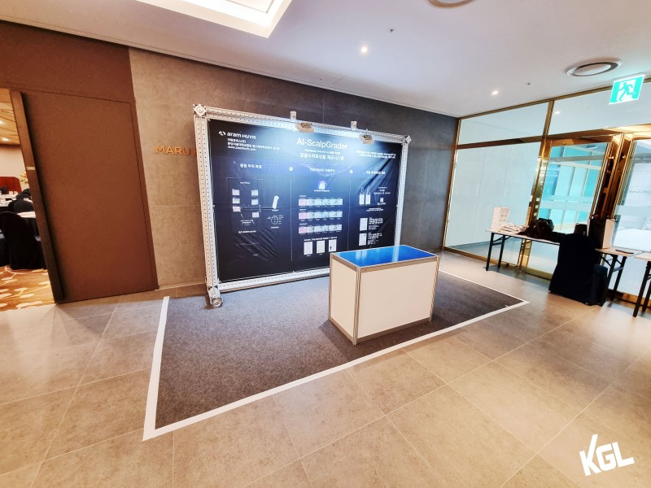

- Please e-mail the application form and CI(Corporate Identity) file(format : ai & jpg) to the STO SUMMIT Secretariat.(email : gaic@edaily.co.kr / gaic.edaily@gmail.com )
- Upon receiving the application form, the secretariat will issue an invoice for the exhibition fee and bank account information.
- You are requested to pay the exhibition fee by September 15th.

Signature Date

